REQUEST FOR INFORMATION (RFI)
RFI #: Passenger Information systems - 156/2025 |  | SUBMITTED TO:
DATE:
NEEDED BY: |  | SUBMITTED BY:
PROJECT:
PROJECT #:

BACKROUND AND PURPOSE OF THE RFI
NTA Metropolitan Mass Transit System Ltd. ("NTA") is the company responsible for the design and construction of a mass transit system for the Tel Aviv metropolis (the "Mass Transit System"). Through this Request for Information (the "RFI") NTA wishes to receive relevant information about technological and innovative solutions, from technology providers which have proven experience with Passenger Information System design and production for Metro network or similar applications.
This RFI is a preliminary process initiated by NTA, solely for receiving information and conducting its initial internal evaluation and consideration.
This RFI does not, in any manner whatsoever, constitute a tender, bid, offer, proposal, or request nor does it constitute an engagement, representation or warranty on behalf of NTA. Response to this request will not constitute a condition for participation in the tender, if any is subsequently issued, and no advantage will be given in the tender to those who responded to the RFI. Based on the responses to this RFI, suitable companies may be invited for further deliberations by NTA, at its sole discretion. Responses are welcome from both single suppliers and / or consortia that can provide a range Digital display solutions.

INTRODUCTION OF NTA
NTA is the governmental company responsible for the development of the Tel Aviv Metropolitan Mass Transit System, a network of light rail transit and future metro railway lines. NTA is leading an economic and cultural revolutionary transformation in the transportation sector by constructing the mass rail transit system of the Gush Dan region. The Mass Transit System is the largest and most complex transportation project in Israel.
The Mass Transit System integrates with all means of transportation, including three Light Rail Transit (LRT) lines and three Metro Lines as follows:
- The Red Line Project (RLP), that has recently commenced operating, extends from Bat Yam to Petach Tikva via Tel Aviv, Ramat Gan and Bnei Brak and is one of the most heavily used traffic corridors in the Tel Aviv Metropolitan area. It stretches, in total, over approximately 24 km, and comprises at-grade sections at both ends and a central underground section of approximately 12 km.
- The Purple Line. The total length of the line will stretch over approximately 27 km, with 46 stops. The line is entirely at-grade and includes bridges. At the eastern end of the line, a depot for heavy maintenance is located. Two Stops will be located on the bridges.
- The Green Line. The line connects between Rishon Le Zion at the south, Tel Aviv in the middle and Herzliya at the North. The line is 39 km long, with 4.5 km running underground. It has 62 stops, 4 of which are underground.
- The Metro System network includes 3 lines:
- The first line (M1) is 85 km long and includes two branches from the south and two from the north joining in a common section along the Ayalon-Namir corridor
- The second line (M2) is 25 km long and serves the eastbound corridor from Petah Tikva to Ramat Gan, Tel Aviv and Bikat Ono.
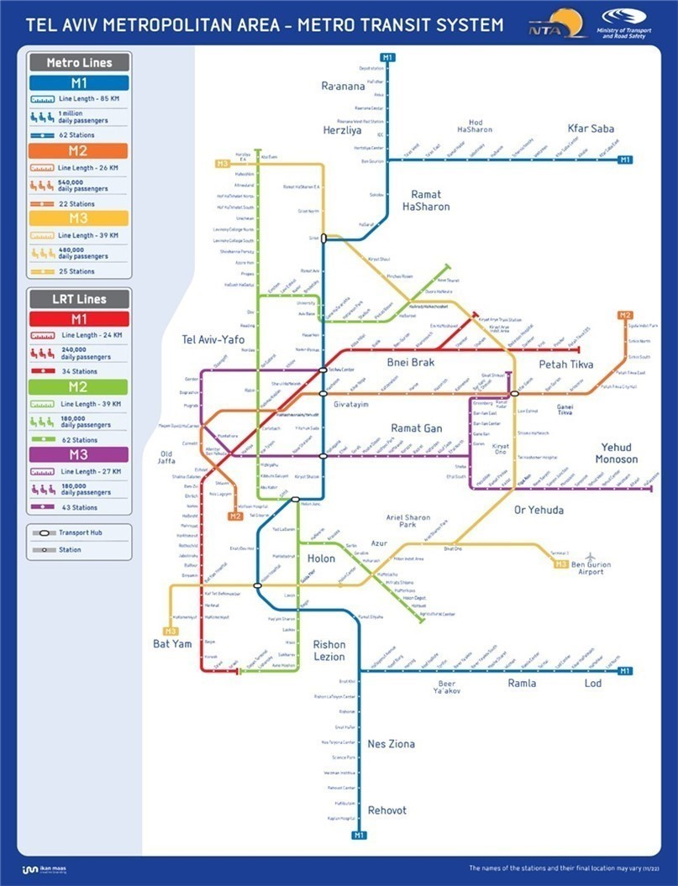
The third line (M3) is 32 km long and connects Tel Aviv north coast to the south coast via a half-ring to the east.

SPECIFICATIONS FOR REQUESTED SOLUTIONS
Responses to this RFI are welcome from Suppliers / Consortia which have proven experience with Passenger Information systems for similar projects and are developing innovative solutions for the next generation of Metro Network that satisfies the criteria summarized below.
- Smart display integration within Metro Trains and Stations
- Smart glass for train windows and station environments
- Sensor-driven real-time information (e.g., coach occupancy, train schedule, environmental data, OB-equipment health )
- Next-generation display solutions such as holograms, augmented reality (AR), and projection-based systems
Note: Not all criterias must be met.
Enhanced User Experience elements that incorporate art, placemaking, inclusivity, accessibility and what level of testing and validation has been conducted with end user groups to determine overall system usability.

A LIST OF DATES FOR THIS RFI
- Date of publication of the RFI – 28.4.2025.
- The deadline for submission of clarification questions by the Participants – 28.5.2025.
- The deadline for submission of responses to the RFI – 30.6.2025.

COMMERCIAL CONFIDENTIALITY AND WAIVER OF CLAIMS
- NTA may use any information it receives during or in connection with the RFI from a Participant or any third party (the "Information") for any purpose it deems fit, including for preparing specifications, tenders or any other documents. In addition, NTA may transfer any such Information to any of its consultants or any person on its behalf. The supplier of the Information waives all claims and demands of any kind against NTA in connection with NTA's above-mentioned rights, including (but not limited to) copyrights, commercial confidentiality, privacy, etc.
- Without derogating from the above, the Participants may mark, in a clear, complete and legible manner, Information contained in the Response which is considered commercially sensitive or of a confidential nature. To the extent permitted by applicable laws, and at its sole discretion, NTA shall consider refraining from disclosing such Information (if so requested).
- The Participant declares and confirms that the provided information is free from any violations of third-party rights, including (but not limited to) copyrights, commercial confidentiality, privacy etc. The Participant shall bear full and exclusive responsibility for any claims or demands arising from such third-party rights violations subsequent to this RFI, and all related expenses will be solely borne by the Participant.

INSTRUCTIONS REGARDING THE SUBMISSION OF THE RESPONSE TO THE RFI
- Participants are free to choose the questions to respond to, based on their expertise and experience. It is not mandatory to respond to all of the questions.
- The Participants are requested to fill-in all the information on Annex A. Each question should be addressed separately.
- It is recommended to attach supporting information in a visual format such as presentations, videos, photos, brochures, etc.
- The response to the RFI shall be submitted in English. Appendices and technical specifications can be attached unlimited in scope.
- The response to the RFI must be submitted in a digital copy by the deadline for submitting responses, as specified in section 5 above, via email: Tender2@nta.co.il. The email’s subject line will state: "A response to RFI to receive relevant information about technological and design innovative solutions for PIDS
(Passenger Information Display System)”.
- NTA may postpone the response submission deadline at its sole discretion. A notice to that effect shall be posted on NTA's website and shall specify the new response submission date.

EXAMINATION OF THE RESPONSE
- NTA reserves the right, at its sole discretion, to contact, as necessary, all or some of the Participants with requests for information and clarifications, for presentations and demonstrations, for visits to the Participants' sites and the sites of their clients, etc.
- As part of the response examination process, NTA reserves the right to invite any Participant to present the solution proposed by it to a professional team on its behalf at a location and at a time determined by NTA.
- As part of the response examination process, NTA reserves the right, at its sole discretion, to invite all or some of the Participants to launch a pilot project.

QUESTIONS AND CLARIFICATION REQUESTS
- Clarification questions regarding this RFI must be submitted only in writing, via e-mail to NTA's contact person, as specified in section 10 below. The questions must be submitted no later than the deadline for clarification questions as detailed in section 5 above.
- The Participant must verify that their questions were received by the contact person, as specified in section 10 below, by phone.
- NTA reserves the right to conduct one or more rounds of clarification questions at its sole discretion.
- The clarification questions will be submitted in English, in the following format:
Number of the section in the RFI | Question
- Answers to the clarification questions will be posted on NTA's website.
- Clarification answers will be worded in a way that does not reveal the identity of the inquirer.

RESERVATIONS AND NTA'S DISCRETIONS
- NTA may publish a new Request for Information, an invitation to pre-qualify, tender proceedings and/or any other proceedings with respect to the Project or any part thereof and/or with respect to any other project whatsoever, in any manner which it will deem appropriate. Without derogating from the above, NTA may pursue any engagement based on the information submitted in this RFI, whether through the conduct of a bid or a tender, or without conducting such proceedings, as NTA deems fit.
- NTA may request additional information (in writing or otherwise) as it deems necessary, request to visit sites or facilities constructed or operated by the Participant or carry out professional inquiries regarding any Participant (including by way of contacting third parties(.
- The Participants shall not be entitled to any payment for the information provided by them pursuant to this RFI. All expenses incurred by a Participant or anyone on its behalf shall be borne solely by the Participant. Participants shall not be entitled to any reimbursement or compensation for expenses in connection to their participation in this RFI.
- NTA shall not be responsible or liable towards a Participant or anyone on its behalf in connection with this RFI, including in connection with information provided by or to NTA pursuant to or in connection with this RFI.
- NTA may amend, withdraw or cancel this RFI, at any time and without providing reasons or justifications for doing so.
- This RFI is subject to the law of the State of Israel, including the Mandatory Tenders Regulations, 5753-1993 and the obligation to disclose information in accordance with Section 14A thereof.

CONTACT PERSON ON BEHALF OF NTA
The contact person on behalf of NTA regarding this RFI is Moran Hen, email moranhe@nta.co.il.

ANNEX A - RESPONSE TO THE RFI
General:
- This Appendix must be digital.
- Additional information should be attached to the relevant Appendix.
- It is recommended to attach supporting information in a visual format such as presentations, videos, photos, brochures etc.
- Information about the Participant:
Supporting documents for questions 1-2 below shall be attached in a separate file captioned "Appendix 1".
1. General details regarding the company submitting the response (the "Participant"):
Participant's name:
(Name of company or individual submitting the response)
Classification of the Participant: (corporation, association, authorized dealer, independent consultant, etc.)
I.D number/Company Registration Number:
Contact Person:
(Full name, position)
Address:
Phone no.:
E-mail:
2. Details about the Participant's knowledge and area of expertise and the relevance of the Participant’s experience to the Project.
- Information about the proposed “Solution/s”:
* Documents supporting answers to questions 3-8, complying where possible with the “Specifications” listed in section 4, will be attached in a separate file captioned "Appendix 2".
P.N. Responses to this RFI are welcome from Suppliers / Consortia with relevant experience in Passenger Information Systems for metro or other complex transportation projects, or who can demonstrate innovative and applicable capabilities relevant to such systems.
- Smart Display Integration (Trains, Stations and OCC)
  - What types of smart displays do you offer for:
  - Inside metro trains: (e.g., overhead screens, seatback displays, interactive panels, smart glass windows etc.)
  - Outside the train: front, side and back electronic signs
  - Metro stations: (e.g., platform screens, concourse signage, interactive kiosks)
  - Metro stations integrated fare information digital signs – destinations\distances & fares display, station ID QR codes
  - Passengers' information – provide crossing/network transport lines information
  - What display technologies are used (opaque or transparent screens or a combination of those technologies, projection-based systems etc.)?
  - How does smart glass support the display of interactive content (route maps, AR overlays, advertising, and emergency notifications)?
  - What safety, maintenance, and durability standards are met by your smart glass products? Please indicate compliance with environmental and durability standards including heat, humidity, corrosion, dust, vandalism, and EMI
  - How is your display's screen quality (e.g., contrast ratio, color accuracy, brightness, vividness) compare to competing products?
  - Are your smart screens offer real-time dynamic content display or adaptive refresh capabilities?
  - What kind of touch technology do your screens use (e.g., capacitive, resistive, optical)?
  - Do your smart displays support the latest AI or voice control technologies including information for people with disabilities?
  - What operating systems or platforms do your smart displays run on (e.g., Android, Tizen, proprietary OS)?
  - Information on Video Wall Technology – LED Video walls, MicroLED, OLED, HDR, Ultra HD/4k and various technologies like LED COB and LED MIP.
  - Do your displays include anti-glare or anti-reflective coating, and vandal-resistant material?
  - What is the viewing angle supported by the display (please confirm if 178 degrees or more)?
  - Do your displays support remote monitoring, centralized content management, and dynamic content updates based on time-of-day or station traffic?
  - How frequently can system content (e.g., route maps, announcements, schedules) be updated? Does the system support automated, real-time, or scheduled content updates, and what is the typical update workflow?
  - Do the displays include advanced thermal management systems for operation in harsh environments?
  - Please specify whether screens are industrial-grade and support 24/7 operation as per manufacturer specifications.
  - Please indicate compatibility with LED (including MicroLED) or LCD technology, and indicate if DS (double-sided) screens are supported.
  - Final screen sizes will be determined based on site-specific measurements. Does your solution allow flexibility to accommodate final design adjustments?
- Sensor-Driven Passenger Information
  - How does your system integrate with metro control centers, IoT sensor networks, and external data sources (coach occupancy, train schedule, weather data)?
  - How is sensor data processed and displayed to passengers on digital displays, holograms, or AR platforms including direct information for passengers with wearable equipment and mobile devices to get location-based information
  - How do your displays support real-time passenger information, including service updates, disruptions, and emergency alerts?
  - Does your system offer predictive analytics, such as forecasting train occupancy or environmental conditions?
  - Does your system include offline modes, caching, or fallback mechanisms to ensure critical passenger information remains available during network failures or emergencies?
  - Does your solution include a management dashboard for data visualization, report generation, real-time monitoring, and obtaining operational insights?
- Innovative Display Technologies (Holograms, AR, & Digital Art)
  - Do you offer holographic display solutions, and how are they applied for passenger guidance, travel updates, or interactive advertisements?
  - How does your solution integrate augmented reality (AR) to provide an immersive wayfinding experience or overlay cultural and historical content?
  - What interactive digital art installations or projection mapping technologies can be incorporated to enhance the metro environment and contribute to placemaking?
  - How do these systems perform in high-traffic, public transit settings and across the variations of environmental conditions to manage issues such as reflections and glare, ambient noise variations and overall system readability/audibility/usability?
  - Do your displays offer support for interactive signage or digital signage applications?
  - How do your displays handle power efficiency, in terms of sustainability? Please describe how your solution uses light sensors and energy-efficient practices to reduce power consumption and carbon footprint.
  - Have you incorporated advancements like foldable screens or transparent displays into your product range?
  - What upcoming innovations or features are you planning to introduce in future models of display screen?
- Enhanced Passenger Experience & Inclusive Design
  - What multimodal interface options do you provide (touch, voice, gesture, haptic feedback) to ensure that all passengers—including those with disabilities—can easily access information?
  - How do your solutions personalize content based on user preferences or accessibility needs (e.g., language, color and contrast, font size, audio cues)?
    - Does your solution support displaying information in multiple languages simultaneously? Please specify which languages are supported and whether additional languages can be added upon request.
    - Does your solution support localization for Hebrew, including right-to-left (RTL) formatting, Hebrew fonts, and local date/time/number formats?
    - Does your solution fully comply with Israeli accessibility standards and regulations, including requirements for visual, auditory, and cognitive accessibility across all interfaces and content displays? If not fully compliant at present, can the system be adapted to meet these standards upon request?
  - Can your system integrate immersive soundscapes or adaptive lighting to enhance ambiance and provide dynamic wayfinding cues?
  - Do you support gamification or community engagement platforms that encourage passenger interaction and promote a sense of community?
  - How do your solutions incorporate inclusive design principles to ensure the system is welcoming and usable by all demographics?
  - What level of user testing and validation has been conducted, what user groups have participated in formal user testing, what were the outcomes/lessons learned and how have these have influenced the final design solution(s).
  - Does your system collect anonymized usage data (e.g., dwell time, interaction points, language preferences)? If so, how is this data made available for operational insights?
  - How do your solutions perform across the variations of environmental conditions to manage issues such as reflections and glare, ambient noise variations and overall system readability/audibility/usability?
  - How easy is it to develop and integrate custom applications or services for your smart displays?
  - How do you provide unstructured information to passengers such as: upcoming fare changes, service disruptions, emergency alerts and instructions.
  - How do you encourage passengers to use self-service websites or ticketing machines?
- Connectivity & System Integration
  - What network connectivity options (5G, Wi-Fi, Bluetooth, NFC, IoT protocols) are supported by your solutions?
  - How does your system integrate with ticketing systems, crowd management tools, and smart city infrastructure?
  - What cybersecurity and data protection measures are implemented in your system to ensure the security and privacy of all passenger interactions and sensor data flows, and to prevent unauthorized access, data breaches or disruptions to public services?
  - Does your solution support integration with existing or future third-party systems (such as signage, control, customer service, etc.)? Please specify the integration method and supported protocols.
  - Is your system connected to a central control system (such as OCC)? Can content be managed remotely for each screen individually?
  - Does your CMS support modular scaling, allowing for seamless addition of future screens without system-wide changes?
  - Does your CMS support multi-user access with tiered permission levels (e.g., administrator, content editor, viewer)? Please describe user management capabilities.
- Can your system be piloted or tested before a full-scale deployment, and what are the evaluation criteria?
C. Information regarding maintenance of the proposed Solution:
* Documents supporting answers to question 9, will be attached in a separate file captioned "Appendix 3".
- For each unique solution proposed: What maintenance, support, and upgrade services do you offer? What maintenance and durability standards are met by your smart glass products?
Integration:
  - What regulatory approvals, standards, or certification processes are required for implementing your solution in Israel or the European Union (if applicable)? Does your solution comply with standards such as CE, ISO, ADA, etc.?
  - Do you have a customer service and technical support presence in Israel? If not, how is support provided (location of service center, hours of operation, SLA, spare parts availability, etc.)?
  - Do you provide training programs and documentation for system operators and maintenance teams as part of the deployment or handover process?
- Future-readiness
  - How is your solution prepared for future technological changes, including software upgrades, hardware updates, or regulatory adaptations?
  - Do you have a technological roadmap for the coming years?
D. Additional relevant information about the proposed technological Solution/s or other solutions/functionalities relevant to the scope of the project.
* Documents supporting further information will be attached in a separate file captioned "Appendix 4".

RESPONSE BY: [NAME, TITLE, COMPANY] |  | DATE:
ATTACHMENTS:

